|  |
| --- |
| 新东方在线英语学习 |
| 新概念 1 册 |
| Lesson37-38 |



扫一扫。更多有趣的英语资讯。

# Lesson 37 单词讲解

1. work: 工作

I work in NO School. v.

1. hard: 努力地 adv. (副词)
   1. 副词的功能：用来修饰 adj.\ v.\ adv.

※ 修饰 adj.

* + - I am tired.
    - I am too tired.

※ 修饰 v.

I love you.

* 1. 副词的位置：通常情况，形前动后 I swim well. 我游泳游的很好。I know him well. 我很了解他。
  2. hard 词性讨论：

hard work:艰苦的工作

work hard:努力的工作

1. make: 做

What make is it? 这是什么牌子的？

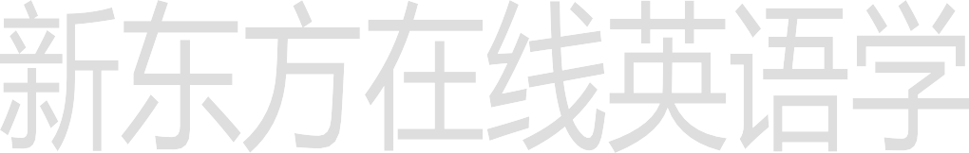make the bed: 整理床铺

make a bookcase\ bookshelf: 制作一个书架

1. bookcase: 书架
2. hammer: 锤子
3. paint: 涂色，上色

painting: n. 画

Chinese paintings 中国国画

1. pink: 粉色的
2. favourite（favorite）: 最喜欢的favorite fei wu er ruite
3. color \ city \ school \ book \ girl What’s your favorite…?

Who’s your favorite…?

# Lesson 37 课文讲解

1. You are working hard,… 你正在努力工作。你正忙着呢！
2. Give me…
3. I ’m going to paint it (the bookcase) pink.

主 谓 宾

宾补：对宾语的补充和说明，使句子更加简洁。我发现那屋子是黑 的。

I find the room is dark. I find the room dark.

主 谓 宾语 宾补

我们必须让这屋子暖和点。

We must keep the room warm.

大家务必保持教室的干净。

We must keep the classroom clean.

历史使人明知。 Histories make men wise. 诗歌使人灵秀。Poems make men witty. 数学使人缜密。Math make men subtle.

哲学使人深刻。Philosophy make men deep.

1. It’s for my daughter. for:
   1. 为了…某人而… It’s for you.
   2. 对于某人来说…math is so difficult for me
   3. 表原因… what are you sorry for?
   4. 长达… I study Yoga for two years.

# Lesson 37 语法讲解

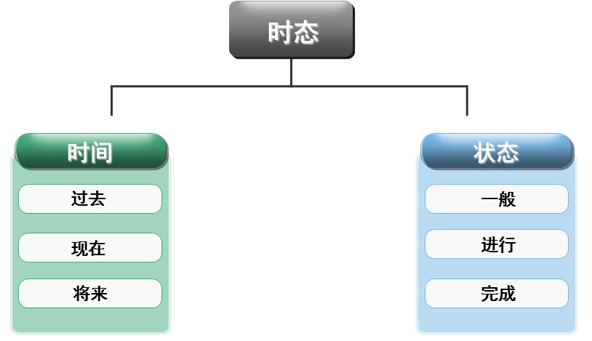

be going to 句型

1. 何时用？
2. 固定形式:
3. 小小要求: 后面接动词原形我打算周末去逛街。

I am going to go shopping this weekend.

他打算把旧车卖了买辆新的。

He is going to sell his old car, and buy a new one. I am gonna be happy this year.gou na 仅仅口语

口语中: be going to = be gonna I’m going to be happy this year.

※ be going to 句型:

be going to do \ be going to be+ adj. n. prep. … be going to do\ be going to be+ adj. n. prep. … 我打算下周开始忙起来。

I am going to be busy next week.

他计划这周末呆家里。

He is going to be at home this weekend.

这个孩子打算以后成为医生。

This kid is going to be a doctor.

1. be going to 句型的其他形式： 疑问: be 提前

否定: be+ not

她打算周末去逛街。

She is going to go shopping this weekend. Is she going to go shopping this weekend?

She is not going to go shopping this weekend.

# Lesson 38 单词句型讲解

1. homework: 家庭作业

housework: 家务活

1. listen: 听

listen to the music\ radio…

1. dish: 盘子dai shi

# Lesson 37&38 知识拓展

